The social care sector needs people with lots of different skills. Each of these photographs illustrates the different types of skills.

Photo 1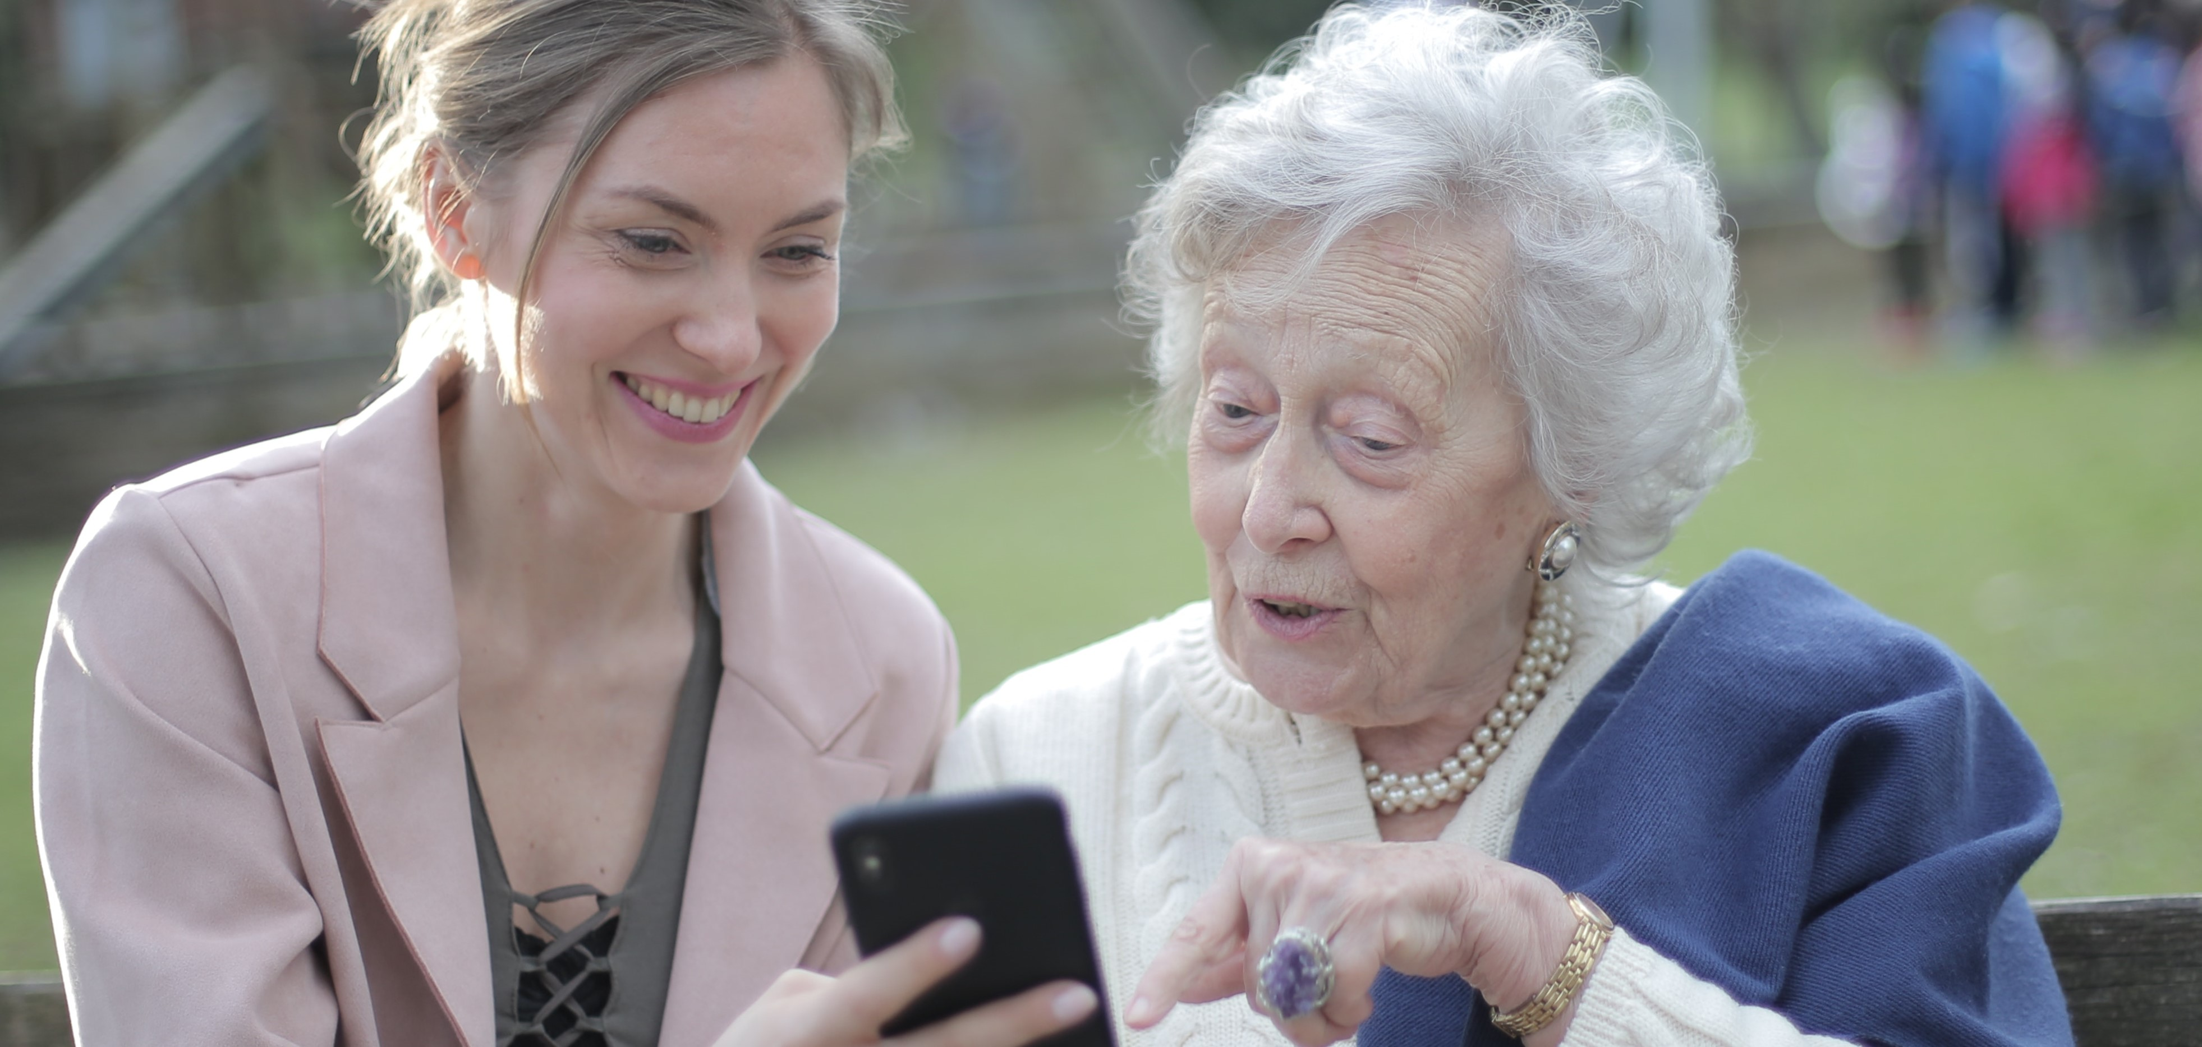
What skills do you think are being shared between the younger and older lady?:

What job do you think the younger man has?
Family worker?
Care assistant?
Community nurse?

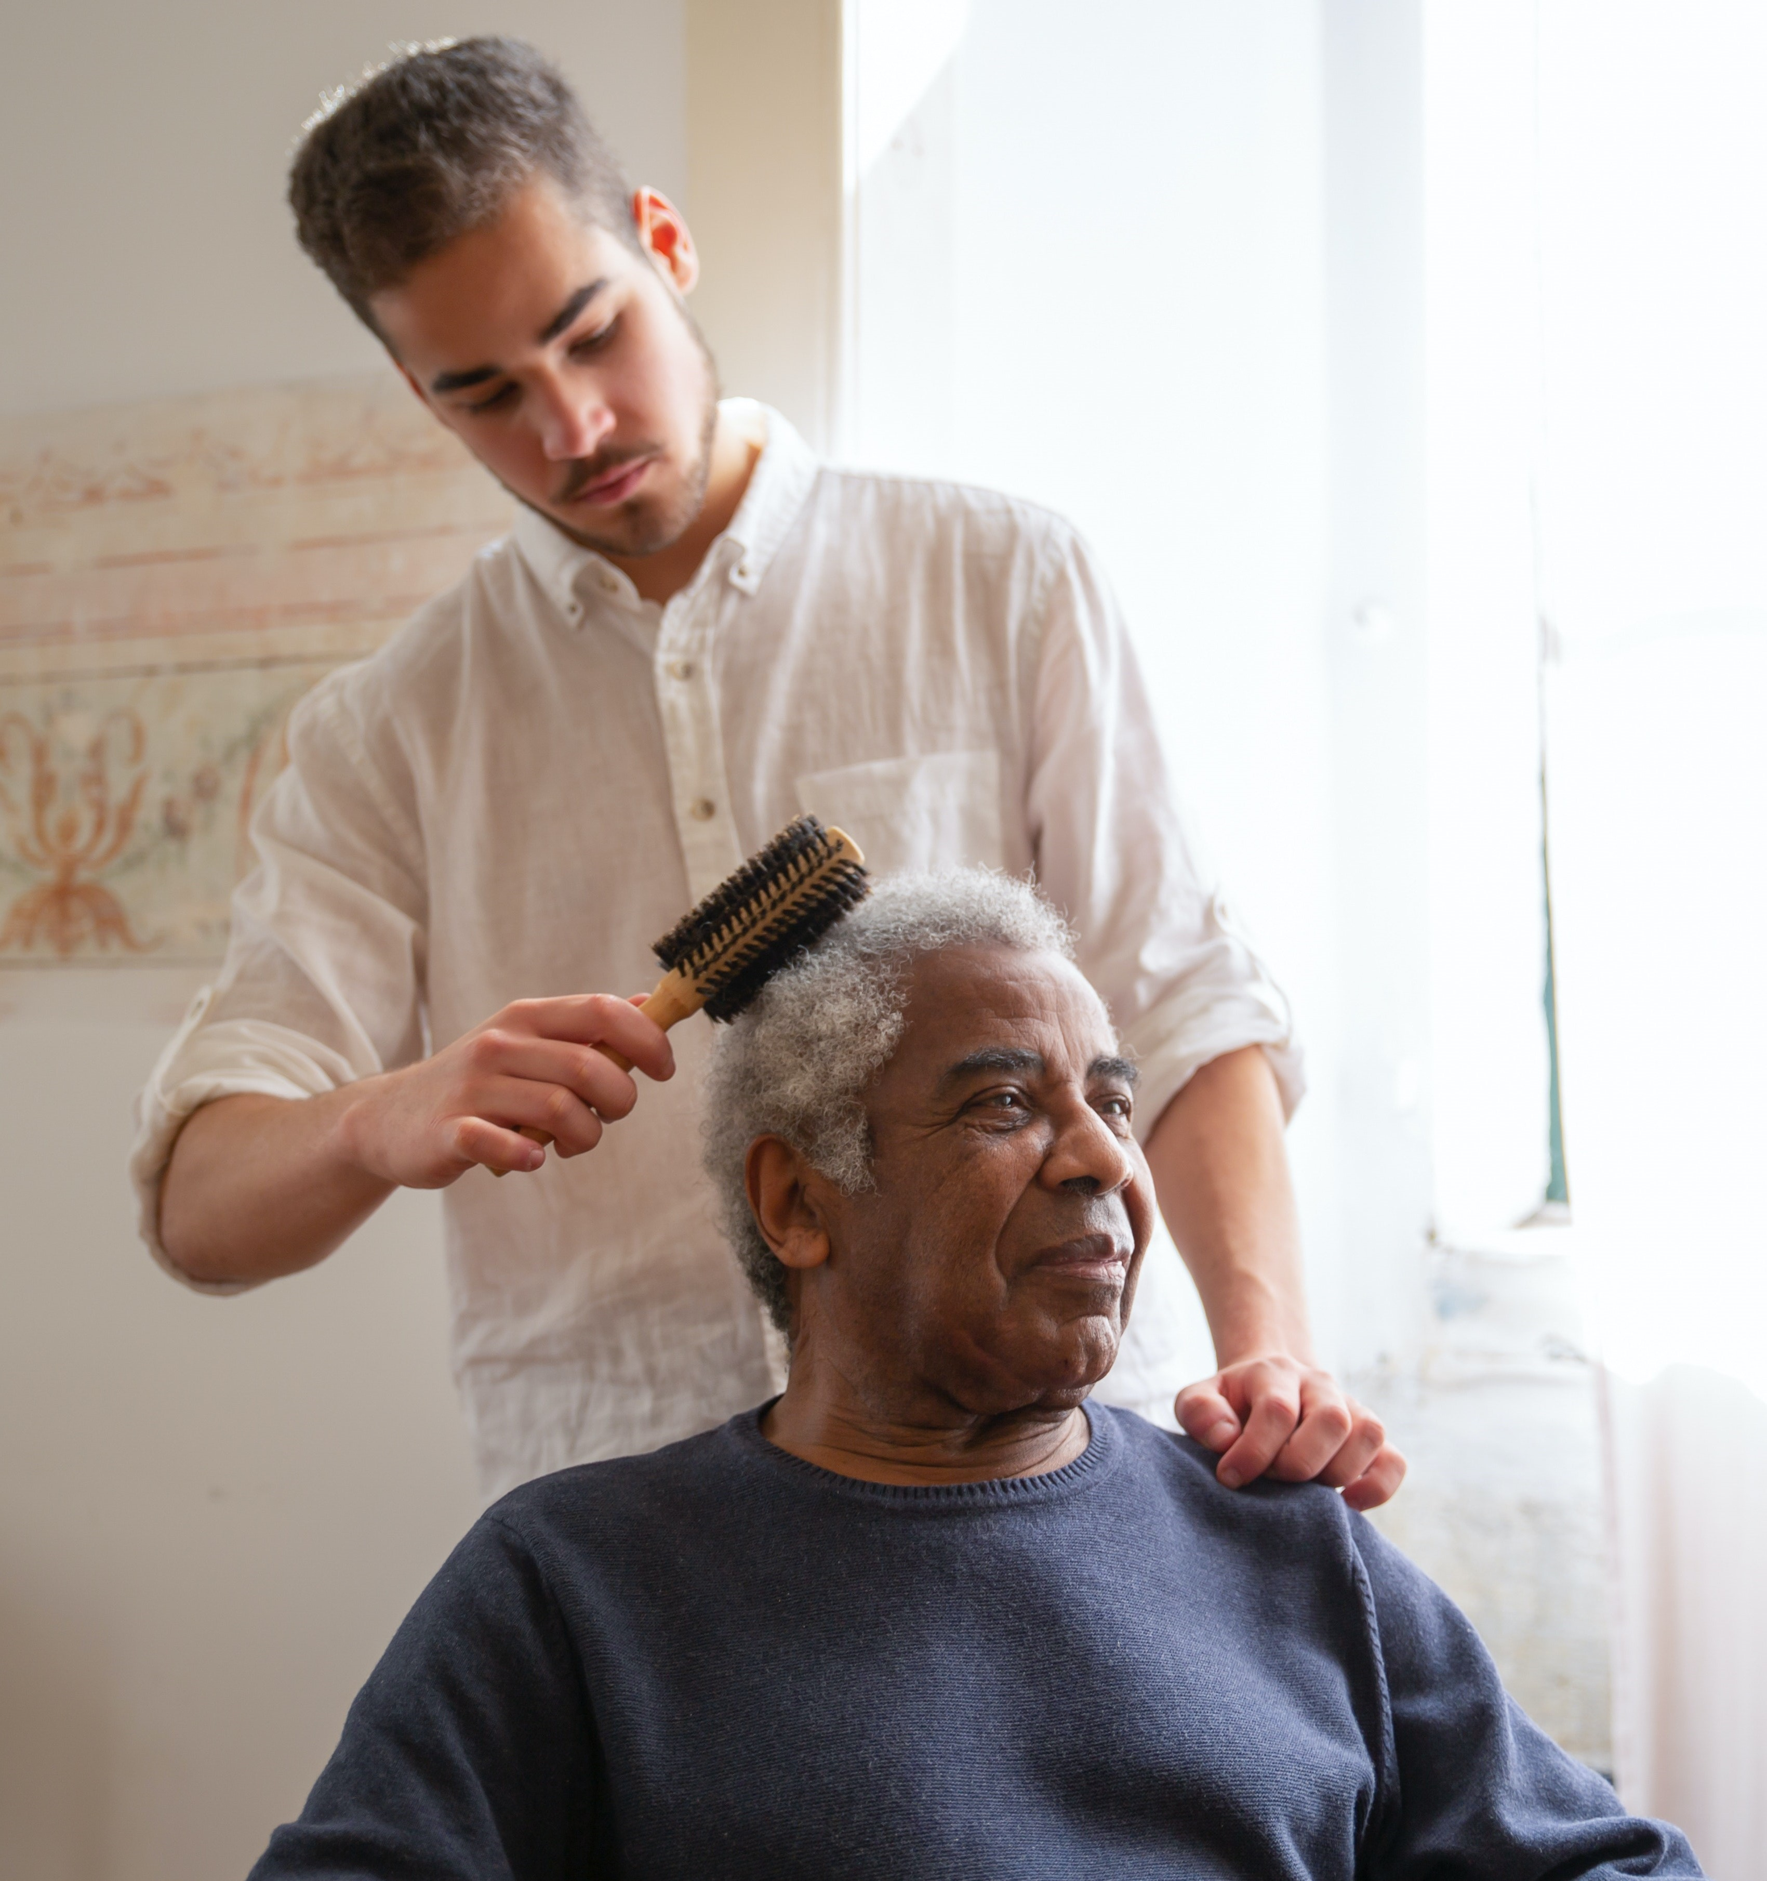

List 10 skills that the young man is using:

1 2

3 4

5 6

7 8

9 10

Which of the skills in your list are the three most important he needs to do his job?

1

2

3

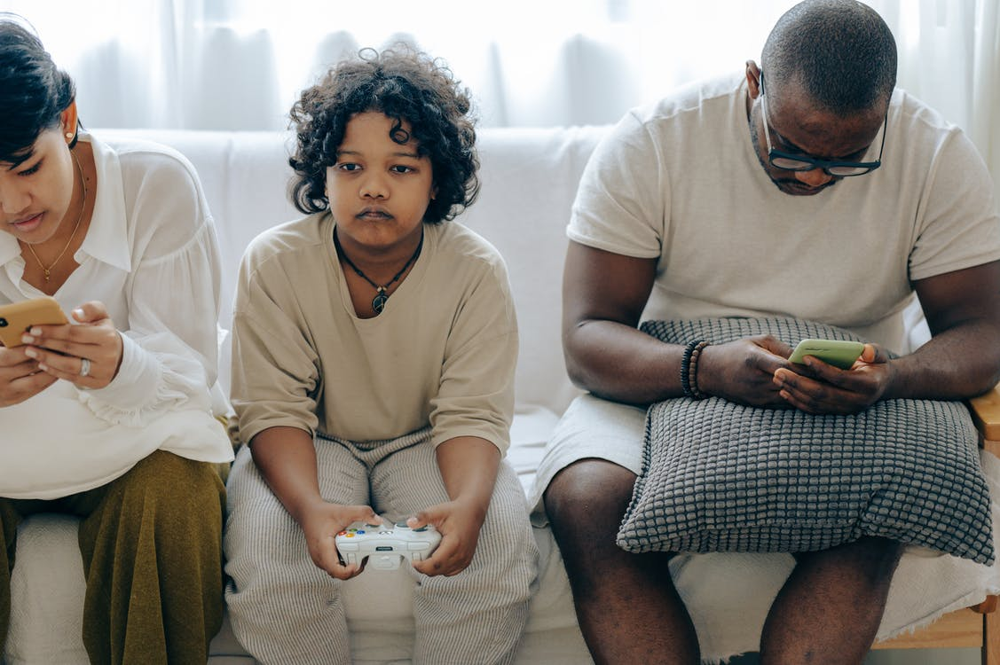

Look at the photograph below.
List 5 good things you can see:

What 2 issues could occur in the future?

How could you help the family prevent them?

Scrambled skills
Can you unscramble the skills needed to be a family case worker?

- MONMNOITCICUA _____________________________________

- NEIIGTSLN _________________________________________

- IAVECD ____________________________________________

- TEWKOARM __________________________________________

- PLEH ______________________________________________

- OETLRUVEN _________________________________________

- GCRINA ____________________________________________

- EYPHATM ___________________________________________

- WSCARKOE __________________________________________

- NELIDYRF __________________________________________

